1. **Mediastack (https://mediastack.com):**

Covers 7500+ news websites for 50+ countries in 13 languages.

Plans: Please refer this website for the same (https://mediastack.com/pricing)

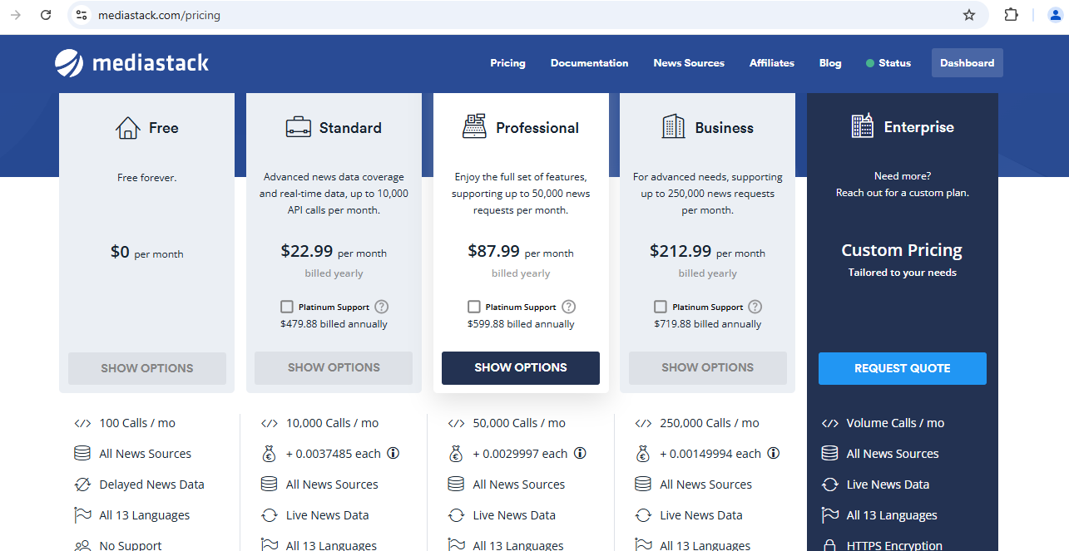

1. **Newsapi (**[**https://newsapi.org/**](https://newsapi.org/)**)**

Covers 150,000 news wesbites from 50+ countries in 13 different languages.

Plans: Please refer this website for the same (<https://newsapi.org/pricing>)

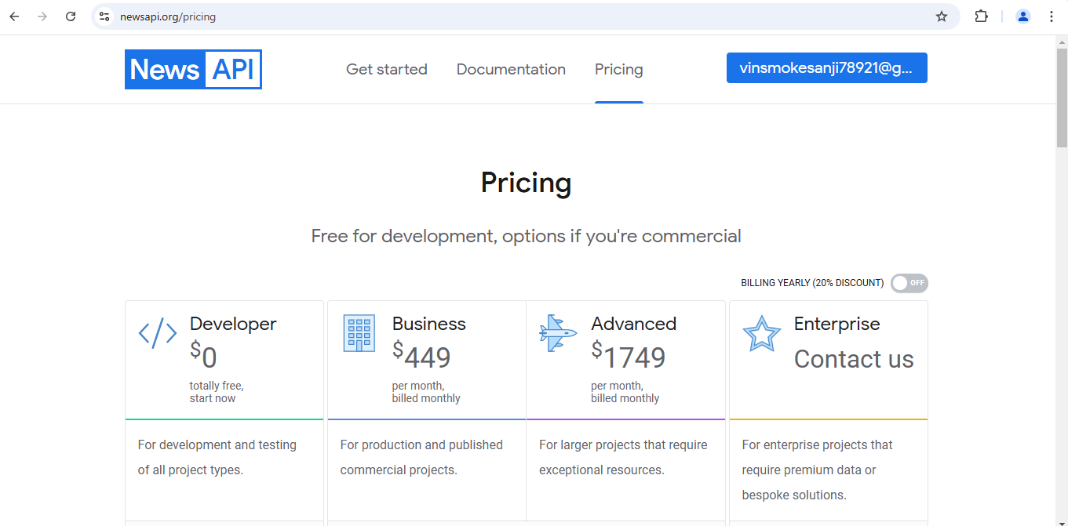

1. **Apify (https://apify.com/):**

For social media posts and descriptions.

Covers twitter, Instagram, linkedin.

Plans: Pay-as-u-go plan. (<https://apify.com/pricing>)

